Student's Name: Jenna Rizzi
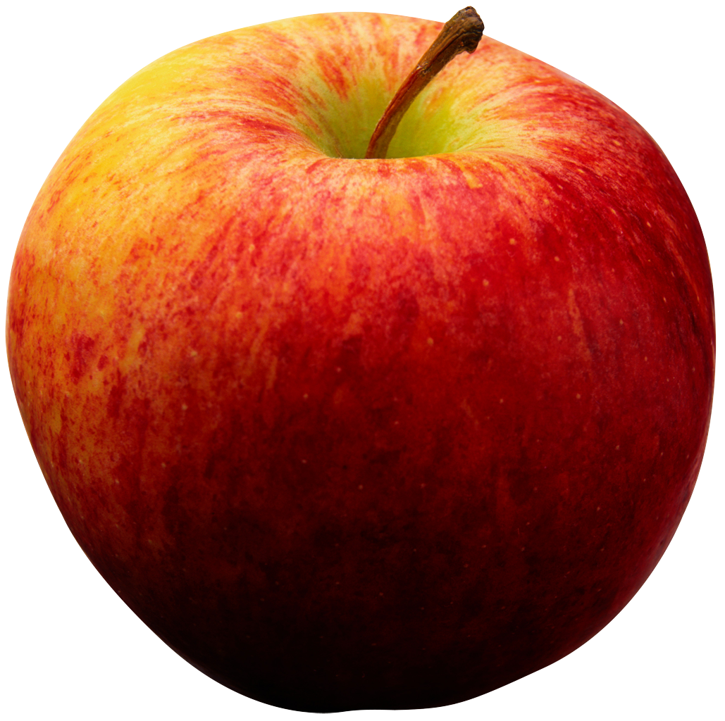
School Name: Orchard Hill Elementary School
Grade Level: K
Host Teacher's Name: Rosita Sheeley

Lesson Topic and Main Concepts (Big Idea):
This lesson will be focused on counting 1-10 with an immersion in the color red for our Red Day of Color Week

Background Information
a) Analysis of Students' Prior Knowledge including misconceptions
Every morning the class sings a Number Rock song to practice numbers one through twenty. Of the seventeen students in our class, all seventeen of the students can count aloud from one to ten as observed with this song and concretely in their beginning of the year assessments. Almost all students can write the numbers one through ten despite mistakes with the numerals. Many students however, hold a misconception about one to one correspondence and do not realize that the numbers they count relate to a specific quantity of objects. Some do not understand that the last number name they counted up to represents the amount of objects counted in the group. They do not understand that counting to ten represents a group of ten objects. This is crucial to understanding further counting concepts such as counting by, 5s and 10s. Being that it is very early on in the school year, the students could really use more practice repeating and writing the numbers.
In addition, I believe that the image of “balancing apples on top of one’s head” will capture students’ imaginations. I believe the students will enjoy being read to, especially with the rhyme and “competitive” nature of the story Ten Apples Up On Top!.

b) Teacher Content Knowledge
Teachers must have a deep knowledge of one to one correspondence and how to best represent this to students. One represents one object and two represents two objects. They must know that there are different ways to express quantity. Object(s) in a set are represented by numerals. In addition, numerals can be represented by objects. They must understand that when counting objects, the last number name said represents the amount of objects in the set.

NJCCCS and Common Core Standards
K.CC.4a-When counting objects, say the number names in the standard order, pairing each object with one and only one number name and each number name with one and only one object
K.CC.4b-Understand that the last number name said tells the number of objects counted. The number of objects is the same regardless of their arrangement or the order in which they were counted

Objectives | Assessments
Students will be able to count one to one to create their own Apples Up On Top with few errors. (Remembering factual knowledge) | Students will write the correct numbers in the correct order when completing the activity
Students will increase their number sense to be able to correlate numbers with quantities with few errors. (Remembering factual knowledge) | Students will write the correct numbers in correct order when completing the activities and in the closing demonstration

Materials
Apples Up On Top! by Dr. Seuss, Published: May 1961 by Beginner Books,
Long pieces of paper (one per student)
Apple cutouts (ten per student)
Glue sticks
Crayons
Pencils
Apples (10)
Sentence strips (one for each student) prepared with apple cutouts
Apple poem written out for students (optional)

B. PROCEDURE
1. Motivational Beginning & Activating Students' Prior Knowledge :
I will engage the students with the following song/poem. This will introduce them to the counting concept as well as the apple theme. It will get them moving, excited and ready to learn.
Five Red Apples
Away up high
In an apple tree
Five red apples
Smiled at me
I shook that tree
As hard as I could
Down came an apple
And mmm mmm good! (Repeat with 4, 3, 2, 1)

2. Logistics/Classroom Management
This lesson should take approximately 45 minutes to complete. Students will begin on the carpet for the hook, story, and explanation of instructions. Next, students will work independently at their desk to complete the activity. Students have assigned tables in which they sit. The supplies such as glue and crayons for the activity are already at their tables. I will have two students help pass out materials for the activity. The paper for the activity will be set up with a small fold so the students know where to draw themselves to have enough room for the ten apples.
The students will then collect back on the carpet for the summary and conclusion of the lesson. For the wrap up of the lesson I will need a student to volunteer. I will call on a student that has behaved well and followed directions throughout the lesson.

3. Lesson Steps
I will begin the lesson by doing the hook song Five Red Apples with the students. I will then read the story Ten Apples Up On Top! by Dr. Seuss. Throughout the story I will illustrate the apple counting on the easel to keep the students engaged. I will do this from one through ten. I will then explain to the students that they will be able to “balance their own apples on their heads”. I will explain to them that they will draw themselves on the bottom of the paper provided and then they will glue ten apples on top of their head and label the apples 1-10 accordingly. I will model this for them first so they know exactly how to do it. After the students are finished we will gather back on the carpet for a review and closure. I will choose a student to lie down on the carpet and I will line up apples on top of his or her head and have the class count along. See closure below.

*Differentiation*
I believe this lesson appeals to all kinds of learners. I will illustrate along with the story to access more learners (visual and auditory) and dramatize the story. During this time I will call on volunteers to help put up one of the apples on top. This will appeal to the kinesthetic learners and be engaging for the class. The poster activity will engage students in varied techniques. The students will do a little drawing, gluing, and writing so if a student is not confident in one of these skills they can shine in others.

For the early finishers, they can practice writing the numbers on their Apples Up On Top headband. They will decorate these and write the numbers above the apple cut outs on the headband. This shows an additional way a set of objects can be represented (linear).

For my especially advanced student, Isaac, I will have him sorting apple cut outs into groups of ten to practice counting by tens.

4. Questions
How many apples do you see now?
What happens if I add one more?
What happens if I take one away?
If I count to eight, how many apples are there on top?
Raise a quiet hand to show me three apples? Show me four? Are they the same or different?
Show me how you apply this to counting things other than apples?
What is the problem with this…(represent 3 apples with the numeral 5)
Using what you know now, can you count a different way? (Backwards, by two’s etc.)
Do you believe you can sing the Number Rock morning song without my help after practicing this counting?

5. Curriculum Integration
This lesson is interdisciplinary because it integrates literature with math. Ten Apples Up On Top! is a book that rhymes and has simple high frequency words that students may recognize. The focus is counting concepts however; the shared reading offers the students a literature rich experience.

6. Closure:
After the students are finished we will gather back on the carpet for a review and closure. I will choose a student to lie down on the carpet in the middle of the circle of students. I will line up apples on top of his or her head on the carpet and have the class count along. I will have the students place the correct number cut out to the apple. The following diagram is the set up:

Students will sit in a circle like I have depicted in orange. One student will lay down in the middle so that all students can see well. The line represents where the apples will be lined up.

7. Follow-up/Next steps:
Using the students’ posters from the activity, I would discuss groups of ten and counting by tens. It would be beneficial to have ten students stand up in front of the class with their posters and count by tens while showing that there are ten apples in each ten. This is an easy and familiar way to represent 100 objects to the students. Another lesson could be estimation with apples in which I would put apples in a basket and ask students “Do you think this is more or less than 5 apples?” etc.

