From: Jenna Rizzi
September 28, 2012
Subject: Family Engagement for Kindergarten

Introduction:

The purpose of this project is to design and implement a program that engages both parents and students in a way that establishes positive parent collaboration and increases student achievement. The teacher must build a bridge from a child’s home experiences to the child’s school experiences. Teachers must always establish positive relationships with parents in order to best support the student.
In the past, Mrs. Sheeley has hosted a variety of Family Engagement nights. Over her many years of teaching, she has held a Family Math Night, Science Night, Poetry Night, and even a Book-making Night. During the Math and Science nights, she had created centers with manipulatives and small activities for students and parents to explore together. During her Poetry Night, Mrs. Sheeley shared her love for poetry and even had some parents share their favorite children’s poems. For the Book-making Night, Mrs. Sheeley had the students write stories and then showed the parents how to assist their children in “binding” their stories using cardboard and other craft supplies.
The PTA at Orchard Hill Elementary School is very involved and proactive in organizing events for families at the school. The PTA hosted the Scholastic Book Fair in early October. To allow families more time to visit the Book Fair, the PTA organized a night where families could shop for books as well as enjoy a DJ and refreshments together. The PTA also puts on an International Night, Market Day and Kids Stuff fundraisers, Family Carnival, Holiday Gift Fair and other fun events to engage both parents and students in the school community.

Rationale and About the Event:

Instilling a passion for reading and the desire to learn from books is imperative in order for students to be good readers. According to Making Meaning (Grade K), students are encouraged to make weekly visits to a library to get immersed in literature. It is no doubt that when students are immersed in literature, they are better readers and writers and their vocabularies are boosted (vi). I believe that good readers are also better learners. It is critical to immerse young students in literature to get their interest sparked and be “hooked on books”. It is important to show young students that there are so many kinds of literature on virtually millions of topics. There is a book for everyone. As an avid goer to three different public libraries, I believe that checking out books from the library is a truly enriching and educational experience. It is so exciting to check out a book that I cannot wait to read. I hope to instill this passion in my students. For my Kindergarteners, I hope they understand that learning to read is a challenging, exhilarating, and sometimes, a frustrating process, but that it is worthwhile and valuable. Being immersed in literature and getting excited about books surely eases this process and promotes life-long learning.
Prior to planning this event, I had informally assessed the need for an event like Night at the Library. After talking to many parents at Open House and Back to School Night, I realized that many of the families were new to the area and were probably unfamiliar with the library. For many of the parents I met, their Kindergartener is their first child and I considered that perhaps the parents are not aware of how enriching the library is for young students. I later asked students if they go to the public library with their parents. Approximately ten out of the thirty-four students had mentioned that they have been there. I strongly believe that this event will engage students and parents from all backgrounds in reading as well as the community.
I would like to implement a family engagement event called Night at the Library. This night will take place at the Montgomery public library: Mary Jacobs Library located at 64 Washington Street, Rocky Hill, NJ 08553. Ms. Rizzi’s Night at the Library will start at 7 pm on Tuesday, October 16, 2012. This night is designed to get parents and students acquainted with using the public library with the hope of getting students hooked on reading. I will begin the event by reading a story to the families. I will read The Best Book to Read by Debbie Bertram. I will then show them different books I have pulled to represent that the library contains books on just about everyone’s unique interests. I will explain that it is fun and exciting to go to the library to check out new books as the reader can learn new things. After this small demonstration, parents and students will be given a short tour of the Children’s Section by Children’s Library Specialist, Karen Bilton. Parents will have the opportunity to obtain a library card at this time and/or check out books. As the parents may be filling out information for a library card, I will read another story to the students, How Rocket Learned to Read by Tad Hills. I will also provide small activities such as coloring sheets and puzzles for families to do together if time permits.
As an added incentive to attend Ms. Rizzi’s Night at the Library, I will be giving out Kindergarten Cookbooks as a gift. I have asked parents and children to work together to come up with their favorite family recipe to submit. The parents were asked to submit the recipe for any dish that their child or family loves. The children were then asked to draw a picture of the dish or ingredients. I have compiled these recipes and illustrations into a spiral bound cookbook and have attached a wooden spoon with a nice ribbon. I will give these to the families that attend the event. The Kindergarten Cookbook is a great way to celebrate cultural diversity in the classroom. I have received recipes of all kinds from many different cultures.

Objectives:
Objectives:
Parents and students will view frequent visits to the library as worthwhile because reading is important and exciting
Parents and students will get acquainted to the Mary Jacobs library and obtain a library card membership

Classroom Demographics:
Mrs. Sheeley’s AM and PM class consists of thirty-four students in total. There are fifteen females and nineteen males. Mrs. Sheeley’s students come from a variety of backgrounds and the ethnicities of the students are extremely diverse. Among her thirty-four students, there are approximately twelve different languages in addition to English, spoken at home. Three of her students have moved to the United States within the past year from other countries. I would estimate students in Mrs. Sheeley’s class come from families of middle to high SES. I would estimate that most of the students’ parents have a college degree. Mrs. Sheeley describes Montgomery SES as “international money”. Montgomery, Skillman, Rocky Hill and Princeton have very high taxes and are all expensive places to live in New Jersey. The pie graph below shows the break down of students by ethnicity:

Assessment:
In order to determine the effectiveness of the program, I will be sending out a short, five-question survey to the parents via email using surveymonkey.com. It will contain the following questions:

1. After attending Night at the Library, did you feel better acquainted with the Mary Jacobs Library?
_____Yes _____No

2. How often do you/will you frequent the Mary Jacobs library with your child?
____once per week ____2x per month ____1x per month ____other

3. Did you obtain a library card at Night at the Library?
_____Yes _____No

4. How can you spark your child’s interest in books and reading?
(Short response)

5. Other questions/comments?
(Short response)

Communications: (see attached)
- Invitation to parents
- Recipe letter
- Recipe template
- Program used on Oct. 16

Ms. Rizzi’s Night at the Library

What: A night for families to get acquainted with the Mary Jacobs public library and most importantly, get children hooked on reading!

Families will have a short tour of the Children’s/Young Adult section of the library and have the opportunity to get a library card and check out books. There will be an exciting Read Aloud by Ms. Rizzi and other fun activities. Families that attend will also receive our Kindergarten Cookbook, a book of our students’ favorite recipes.

Who: Parents and students of Mrs. Sheeley’s AM and PM Kindergarten classes

Where: Mary Jacobs Memorial Library
64 Washington St.
Rocky Hill, NJ 08553 (about 3 miles from OHES)

When: October 16, 2012 at 7pm

RSVP: Please RSVP to Jenna Rizzi by filling out the slip at the bottom and returning it in your child’s folder. Look out for another notice in your child’s folder regarding your family’s favorite recipe!

Thanks for your constant support and all that you do for our class. I hope to see your family there!

Student’s Name________________

_____Yes, we will be attending Ms. Rizzi’s Night at the Library
____ people from my family will be attending

______No, my family cannot attend

Comments/Questions:
Dear Families,

As mentioned in my invitation to Night at the Library, I am looking to compile a recipe book of our students’ favorite recipes. This can be a favorite food of your child’s or something that your family loves to eat together. It can be any dish from dinner to dessert. Every family that attends the Night at the Library will receive a bound copy of our Kindergarten Cookbook!

Directions:
On the page attached you will see two boxes. The box on the right is to write your recipe. Please include the ingredients and amounts, and instructions. The box on the left is for your child to draw the dish or perhaps, the ingredients or their family eating together. I’m sure these dishes will taste just as good as the pictures!

Please return the recipes in your child’s folder by Friday, October 5.

Thank you so much for contributing! I hope to see you at Night at the Library!
“___________________”  by ________________________ | Recipe for:___________  from The ____________________Family  Ingredients:  Instructions:

Thanks,
Ms. Rizzi

Template for Recipe page:

Front and Back of Program Used that Night:

Thank you so much for attending Night at the Library. It is such an honor to work with you and your child. Thanks for your constant support in our classroom!  I hope you and your family enjoy our Kindergarten Cookbook! I cannot wait to try out the recipes myself.  Thanks so much again for coming tonight!  -Ms. Rizzi  PS. Don’t forget to smile | Welcome to  Ms. Rizzi’s Night at the Library
Instilling a passion for reading and the desire to learn from books is imperative in order for students to be good readers. According to Making Meaning (Grade K), students are encouraged to make weekly visits to a library to get immersed in literature. It is no doubt that when students are immersed in literature, they are better readers and writers and boost their vocabularies (vi). I believe that good readers are also better learners.  It is critical to immerse young students in literature to get their interest sparked, “hooked on books”. It is important to show young students that there are so many kinds of literature on virtually millions of topics. There is a book for everyone. As an avid goer to three different public libraries, I believe that checking out books from the library is a truly enriching and educational experience. It is so exciting to check out a book that I cannot wait to read. I hope to instill this passion in my students. For my Kindergarteners, I hope they understand that learning to read is a challenging, exhilarating, and sometimes, a frustrating process but that it is worthwhile and valuable. Being immersed in literature and getting excited about books surely eases this process and promotes life-long learning.  What you as a parent can do:  - Read to your child! Before bed, in the car, at the dentist, wherever!  - Make frequent trips to the library to check out books that interest your child  - Show your enthusiasm for books and reading  - Encourage their reading and writing skills by telling them something specific that impresses you about their work. For example, “I like how you used the pictures to help you read the text.”  - Encourage thinking skills and creativity by asking them to make predictions about a story or making up their own ending | Tonight’s happenings:  Greeting  Read Aloud by Ms. Rizzi  The Best Book to Read by Debbie Bertram  Address to Parents and Students  Mini Tour of the Children’s Section  Read Aloud by Ms. Rizzi  How Rocket Learned to Read by Tad Hills  Farewell and Cookbooks  Throughout the night, parents will have the opportunity to obtain a library card! Please see the library staff and have a driver’s license ready!

The College of New Jersey
ELE/ECE 498
ELEM/ECED 690

Parent Engagement Project Approval Form

I have read the Family Engagement Project proposal entitled:

Night at the Library

and written by:

Jenna Rizzi .

I approve the implementation of this project.

Rosita Sheeley 10/10/12
Cooperating Teacher Date

Kathleen Scotti 10/12/12
Principal Date

Post-Event Analysis

Description and Implementation:

Night at the Library was implemented as planned on October 16, 2012 at the Mary Jacobs Library. The event lasted just under an hour, from 7:00pm to 7:55pm. The night ran smoothly and all families who had RSVP’d as a “Yes” to the event actually attended. Before the event, I placed individual cushions for the children on the floor in front of me and placed chairs in a U shape around the cushions for the parents. There was plenty of seating for everyone. The only revision made was to the itinerary as per the main librarian’s request. The library staff asked that the tour of the library be done first to avoid overcrowding with a Girl Scouts group. The parents, children, and I were very flexible. I made an announcement in my Welcome Address that there would be a slight change in the itinerary. I told them the list of events for the evening beginning with the tour, then the readings, and finally the library card and book checkout.
Starting the night with the tour was an excellent way to start. The children were immediately excited because they got the chance to go “behind the scenes” in the library. The students were introduced to the library offices, the checkout desk and their ultimate favorite, the book drop. The children were jumping up and down with excitement and the parents were thrilled to see their children so happy. I believe this really set the tone for the event.
After the tour, we went to our special event room upstairs and I addressed some of the neat things we saw on the tour with the children. I read the two stories, The Best Book to Read and How Rocket Learned to Read with lots of enthusiasm and expression. I was sure to engage the children, asking questions along the way. I believe the book choices were a hit. The parents seemed impressed that I chose the story that was Mr. Meurer’s favorite pick at the Fall PTA Book Fair. Everyone laughed when two other children at the library who were not part of the event came to sit down to listen to the story too.
I concluded the readings by addressing the parents. I made sure to target my objectives and explain to the parents the importance of reading as well as how they can encourage their children. I introduced our Kindergarten Cookbook that all of the children and parents had contributed to. The families were very excited about these! Many of the children plopped back down on the floor and looked for their entry in the cookbook.
At this point the families were free to check out books and/or register a library card account. I walked around to recommend books and then stood by the checkout counter to see all the families. I was so pleased and astonished to find that out of the eighteen families that attended, eleven registered for library cards! One student even signed up for the monthly Lego Club. I felt very good when the librarians came up to thank me because they were doing me the favor by allowing me to host the event at the library. Seeing the children getting excited over books, their new library cards, and spending time with their families was such a fulfilling feeling. The event went even better than expected and I definitely would do it again with future classes.

Demographic Analysis:

I believe that the demographics shown in the “All Students” graph and the “Present Students” graph above are comparable. They have similar ratios from graph to graph. I feel that the results in the “Present Students” graph are not necessarily surprising because the more students of a given ethnicity in the class, the more likely that ethnicity will have higher representation present at the event. For example, there is a larger population of Asian/Indian students in the class and thus, this population is more likely to have more students present at the event. The Asian/Indian demographic starts with a larger possible amount of students that can attend. In conjunction with this, the minorities of the “All Students” graph (Hispanic and African American) have only one student each and thus are less likely to be represented at the event. They have less of a chance that that one student will attend. The outlier is the Pacific Islander demographic. There was one Pacific Islander student in the class. That one student attended the event and therefore had representation in the “Present Students” graph.
I would be more interested in comparing the students present at the event and how it compares with reading scores. I strongly believe that students that are encouraged to read, exposed to a lot of literature, and frequent the library are stronger readers and writers. Mrs. Sheeley and I have not assessed the students with running records yet however, from looking at the list of students that attended, eleven of the eighteen are high achieving in language arts. When we assess the students I will definitely refer back to this data.

Effectiveness:
I believe that Night at the Library exceeded my expectations. I am very pleased with the feedback I received from the parents. I used www.surveymonkey.com, a free survey generator that sends out online surveys via email and records the results. (View my online survey at http://www.surveymonkey.com/s/P7M2CLF.) I issued out the survey the morning after the event to more concretely determine if I had met my project goals and objectives. Ten out of the eighteen families responded to the survey. The results from the survey are as follows:

Did you feel better acquainted with the Mary Jacobs Library?
Yes- 10 responses
No-0 responses

How often do you/will you frequent the Mary Jacobs Library with your child?
1 x per week- 5 responses
Every other week -3 responses
1x per month- 2 responses
On occasion-0 responses

Did you obtain a library card at Night at the Library?
Yes- 8 responses
No- 0 responses
Already had one- 2 responses

How can you spark your child’s interest in reading?
We had received a description on how to read with kids, taking breaks, asking questions and such. It was nice to see you example this reading style and reinforce to us parents how to help make our kids better readers.
10/18/2012 2:22 PM
Read to her more, talk about books that she reads in school, encourage her to help in selecting books from the library that interest her.
10/18/2012 9:32 AM
He loves books already... but we'll try to take more different kinds of books on more different subjects
10/17/2012 3:13 PM
Great idea to give them their own cards, eva loved having the responsibility and it made her feel big when she picked the books she wanted to read.
10/17/2012 2:33 PM
Find books that are interesting for my child.
10/17/2012 2:30 PM
By reading to her
10/17/2012 1:58 PM
Open a book. They are sponges and love to learn everything they can.
10/17/2012 1:47 PM
Bed-time story telling. Audio tapes/CD's at home/car
10/17/2012 12:09 AM
Find topics interesting for my child.
10/17/2012 11:59 AM
Read before bedtime every single night. Many genres. Encourage non fiction.
10/17/2012 10:43 AM

Suggestions or Comments:
We had a great time. The time was a little late for Tyler as he is asleep by 7:30, but for special occasions like this, it was worth a change of schedule. Thank you for organizing the evening.
10/18/2012 2:22 PM
Anton got his first own library card that night! We go more often to the Princeton library where we also have a card there.
10/17/2012 3:13 PM
Great idea, well done
10/17/2012 2:33 PM
Well done.
10/17/2012 1:58 PM
Another great book is "Rocket Writes a Story", by Tad Hills. It has a lot of the great site words they are learning and also teaches how to build a story. I am sure the library has it. Or Connor would be more then happy to bring her book in to share with the class. I am always interested in new books for the kids. I would love some of your suggestions. Thank you for your time! Connor is really enjoying her experience with you. It's so cute, "Ms. Rizzi this, Ms. Rizzi that.". They are going to miss you after the new year. You are going to be a wonderful teacher!!!
10/17/2012 1:47 PM
Great event, Thank you!!!
10/17/2012 12:09 AM

Even though there were only responses from ten of the eighteen parents that attended the event, I believe the online survey to be very telling and informative. The parent responses I received were very positive. The responses to the question, “How can you spark your child’s interest in books and reading?” prove that I have made my message clear to the parents. They responded that choosing interesting and diverse topics, allowing children a sense of choice, visiting the library, reading often, discussing books, and having children take responsibility for their library books are ways to encourage children to read and love books. This showed me that I met my objective of educating the parents. I believe I also educated the children by reminding them the library is great because it is free to check out books all they need is their library card. The Best Book to Read demonstrated how the library has a huge variety of genres and topics. I was sure to remind the students that the more they read, the better they will become! I believe the students showing their interest and excitement in the library represents that I have accomplished another objective.
For future Library Night events I would consider a few refinements. I would consider having more literature for the parents on hand. I had the key information that I wanted parents to know in the program, but offering extra literature and pamphlets would be a nice idea. Also depending on the size of the library, it may be wise to limit the number of people to the student and their parent(s). While I enjoyed inviting all of the families, siblings included, I found that the younger siblings could be a bit distracting. The survey had brought to my attention that perhaps seven o’clock is a late start time for young children. I chose seven o’clock so that parents would be home from work in time. Keeping this suggestion in mind, for the next library night I would probably have it begin at six thirty or six forty five. For future surveys, I would ask the parents what they thought of my book selections for the Read Alouds. I could tell from their reactions that they were appropriate and engaging but it would be interesting to hear some other suggestions and recommendations.

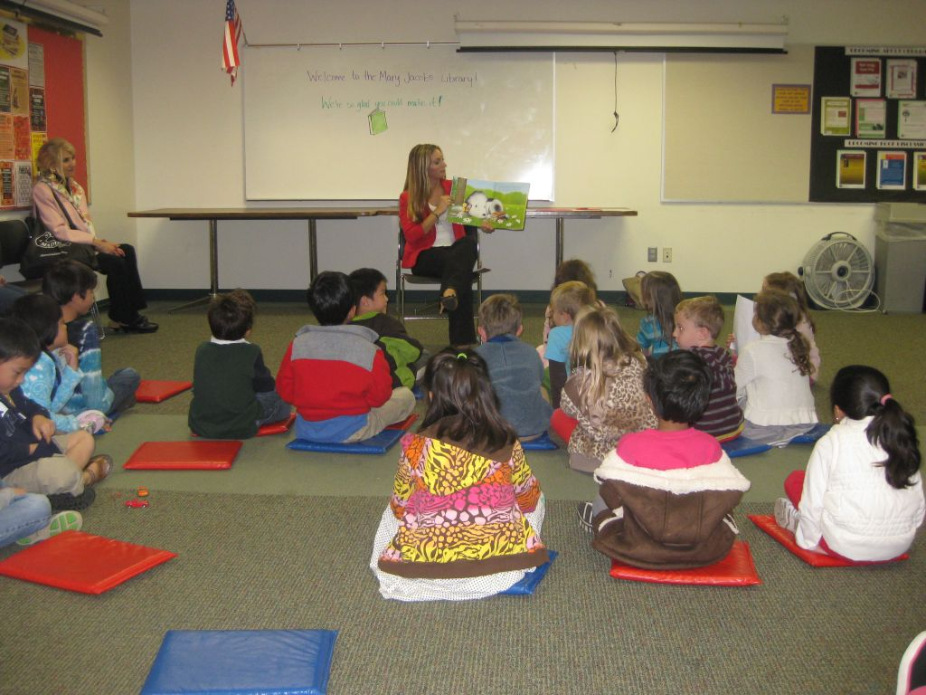
Taken by a parent- 10/16/12

