Freddy Fish and the Pesky Pollutants
Day Seven

Jenna Rizzi
Mrs. Masterson, 2nd grade

Description: This lesson is about pollution and more specifically, water pollutants. It is a demonstration of Freddy the Fish done by Water Watch at The College of New Jersey. The demonstration will simulate the pollution of water and students will be asked to reflect on how Freddy Fish feels about his polluted habitat.

Rationale: Students must learn about water as a natural resource as it is an extremely crucial one to protect. We are trying to instill in students the attitude that pollution is extremely bad for the environment and that each one of them must be conscious about protecting water and the animals that live in the water as they are vital natural resources. In addition, this lesson will also promote the concept of “putting themselves in someone else’s shoes”, in this case Freddy’s.

Prior Knowledge: Students must have some prior knowledge of ocean habitats or what animals live in the ocean. They must know that water is a natural resource as both humans and animals need it to survive. Students may come with the misconception that all water is clean. Assumedly the water they drink and shower with is clean and clear so they may assume that all water is clean. Students will be able to grasp the concepts of this demonstration because at this time, second graders are very empathetic. Their imaginations will be captured as they will almost automatically put themselves in Freddy’s “shoes”. They will feel sorry for Freddy living in the bad conditions and understand how bad pollutants are for the water and other environments.

New Jersey Core Curriculum Content Standards
6.6.2 E.1 Environment and Society
Describe the role of resources such as air, land, water, and plants in everyday life.
6.6.2 E.3 Environment and Society
Act on small-scale, personalized environmental issues such as littering and recycling, and explain why such actions are important.

Objectives | Assessments
Students will be able to recognize basic effects of pollution with 3-5 effects recognized. (factual-understand) | Check worksheet to be sure that the before picture shows Freddy with clean water and the after picture shows Freddy with polluted and dirty water
Students will be able to define pollution with few conceptual errors, some grammatical error (factual-understand) | Check worksheet- definition fill in section
Students will be able to list ways to prevent pollution with 3-5 ways listed (procedural-apply) | Check worksheet-circle correct behaviors
Hook: Show students the following picture: 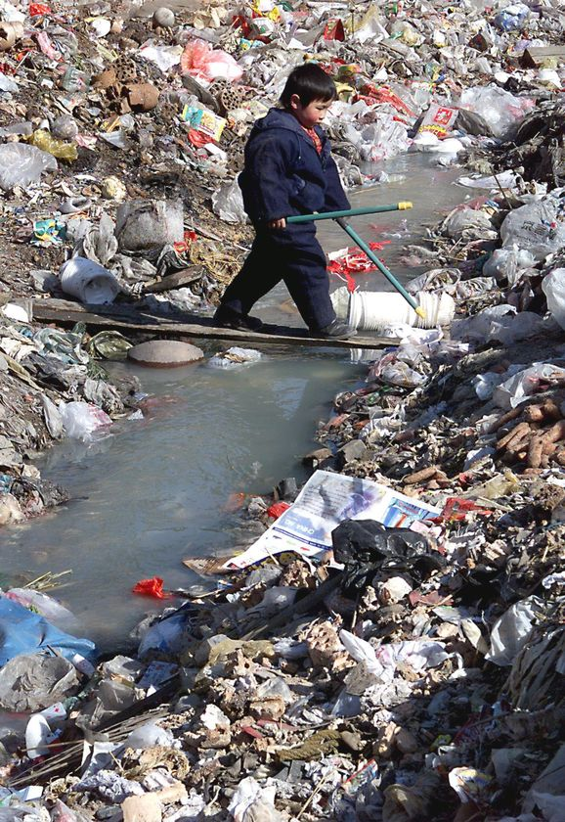 Model about using picture clues, “Hmm I see a young boy in the middle here and it looks to me like he’s standing in the middle of a lot of trash and garbage”. Ask students, “Do you think this looks like a nice place to live?” and “Do you think this is a safe place for this young boy to be?” All of this garbage in this picture is called pollution. We are going to learn about pollution today and especially how it affects my cute little friend, Freddy the Fish.
Activities: We will call all of the students back to the carpet based on behavior at their desks. We will first do our hook to catch the students’ attention and mention the word “pollution”. We will ask the students, “Does anyone know where our friend Freddy lives?” Students should say, “ocean”, “river” or “lake”. We will say, “These landforms are made up of a very important natural resource that we talked about yesterday boys and girls. Who can tell me what it is?” (Answer: water) and “Can anyone name another natural resource that is in the ocean?” (Answer: animals). We will say, “I mentioned a very important word before, put your thumb up if you heard me say the word ‘pollution’?” “How did I use that word?” “Pollution is waste like trash and garbage that harms an environment.” “Let’s see how our friend Freddy feels about pollution in his habitat”. Script:
For this part, engage the students by giving each of them a different “pollutant” to put in to the tank. Say, “Freddie has lived in this clean part of the river his whole life. But now he wants to go on an adventure downstream.
· He passes a farm. It begins to rain, and soil runs down into the water. (dump soil into the water) How is Freddie feeling? Why do you think that?”
· He swims a little more and passes a parking lot. Some cars are leaking oil. “Where do you think the oil goes?” The rain washes the oil into the river. (pour pancake syrup into the bottle). “How is Freddy doing? What do you think this feels like?”
· Freddy swims some more and then swims near schools where some kids don’t throw their garbage in the garbage can. The wind blows and the rain carries the garbage into the river. (pour torn paper inside) “How is Freddy feeling now? Why do you think that?”
· Freddy then swims past a bunch of factories. The factories don’t follow the rules and they dump chemicals and more garbage into the river, polluting the water…. (drop in food coloring etc.)
· “Do you think Freddy can breathe?”
· “Is Freddie Happy or Sad?”
· “Would you like to be swimming with Freddie in this water?”
Students will fill out the poster attached.

Questions: Can you tell me in your own words what pollution is? (remember)
What do you think could’ve happened next if Freddy swam past a factory? (apply)
Could this have happened in an ocean? A river? (apply)
What are some of the problems of pollution? (analyze)
Can you think of some ways you can stop or help pollution? (evaluate)
How would you feel if your environment was polluted like Freddy’s? (evaluate)
What do you think would happen if the water we drank got very polluted? (create)

Closure: We will end the lesson by reviewing the worksheet and concentrating on what students can do to keep the environment pollution free. We will review the ones provided on the worksheet and also open it up to the students to see if they came up with any other ways on their own.

Differentiation/Individualization: For this lesson, the biggest concern will be good behavior and listening skills because it will probably be very exciting to the students. For individuals that cannot handle the demonstration maturely, they will be asked to move back to their desks to watch the demonstration. The Freddy Fish demonstration is very visual and tactile so it will greatly benefit learners. Making the pollution definition part be fill in the blank instead of open ended can differentiate this lesson. Early finishers can make a Stop Pollution campaign poster.
Follow-up Activities: The following lesson is about conservation of water as it is a vital natural resource for Freddy and all other living things. Another follow up activity could be a journaling activity from the perspective of Freddy.

Name____________ __________________________________________
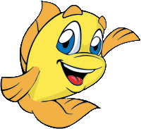
Freddy the Fish and the Pesky Pollutants
Draw Freddy in the river before it was polluted | Draw Freddy in the river after it was polluted
Pollution is_________________________________________________________________
______________________________________________________________________________

Put a check in the box next to the ways that prevent, or stop pollution:
- Recycling
- Throwing trash on the ground
- Taking a bicycle or walking
- Throw all trash in the trash can, no littering!
- Taking cars to places that you can easily walk to

