**Deforestation**

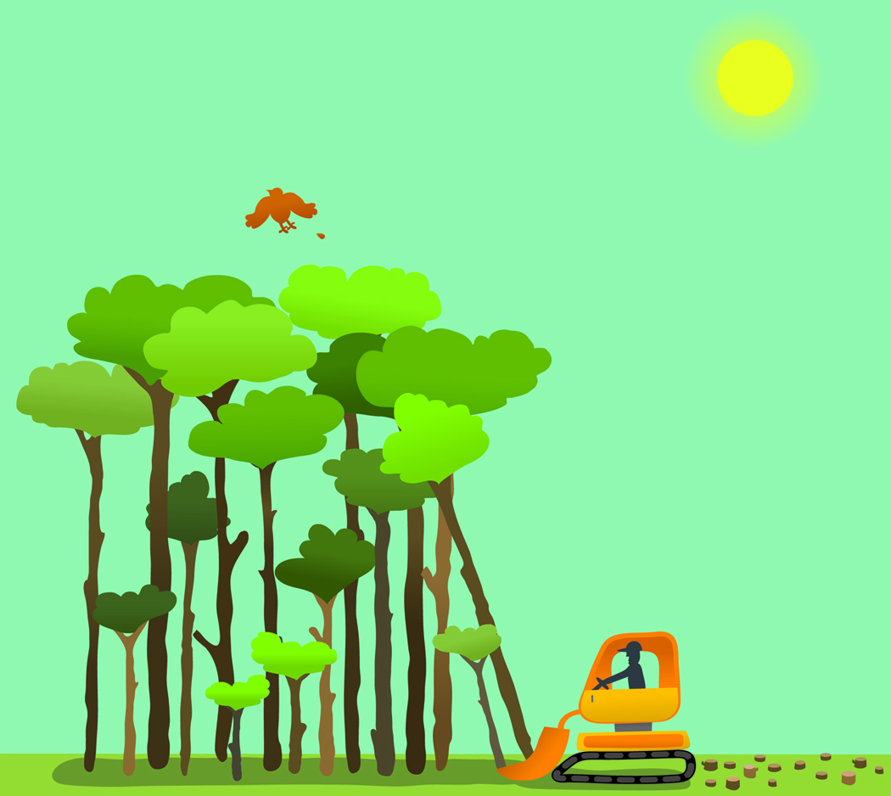

**Day Six**

Jenna Rizzi

Mrs. Masterson, 2nd grade (taught by Jenna Rizzi)

**Description:** Deforestation is the cutting down of trees and forests in order to industrialize or build. Trees are an invaluable natural resource so when deforestation occurs in excess, the detriments drastically outweigh the novelty of having a brand new shopping mall. Trees are a natural resource that we must conserve and value. They are considered a renewable resource but this is only given that they are replanted and not used at a more rapid rate.

**Rationale**: As the students learn about natural resources, they must learn that trees are an extremely vital natural resource that is used for a wide variety of items and tasks. While this resource is considered renewable by replanting trees, students must understand that they cannot be abused. Deforestation can be a devastating thing that can affect their lives at any time. They must learn to appreciate nature and its uses in order to conserve, recycle, and reuse natural resources.

**Prior Knowledge:** Prior to this lesson, students must have basic knowledge about trees. They must understand that we use trees for a wide variety of things and most importantly, we need the oxygen they emit in order to breathe. Students may have the misconception that we can never run out of trees and they may not even know that we destroy trees in order to build things all the time. I think their imaginations will be captured when we are doing the deforestation simulation hook. The students’ imaginations will be captured as they will pretend they are an animal whose habitat is destroyed.

**New Jersey Core Curriculum Content Standards**

6.6.2.E.1 Environment and Society

Describe the role of resources such as air, land, water and plants in everyday life.

6.6.2.E.3. Environment and Society

Act on a small scale, personalized environmental issues such as littering, recycling and explain how such actions are important.

|  |  |
| --- | --- |
| **Objectives** | **Assessments** |
| Students will be able to define deforestation and its consequences | Students will provide answers of positive and negative consequences in order to fill out the comparison chart (as a group), also via Lorax letter template |
| Students will practice writing a persuasive letter | Students will fill out their Lorax letter template |

**Motivational Beginning**: I will give each student an animal name tag to wear. These tags will all be animals that live in a forest habitat. I will ask the students, “Can you think of something that these animals may have in common?” I will allow a few students to answer before saying, “All of these animals live in trees. The forest is their habitat. Today we are going to see what happens when we cut down trees and destroy this particular habitat.”

**Activities**: Present the word *deforestation* to the class. Ask the students if they notice any other words that may be in the word that would clue them into its meaning. (The students should notice the word *forest* in the word.) Ask students what they know or may have heard about deforestation. Tell students that deforestation is the cutting down and clearing of trees in order to build new things like homes or roads. Explain to the class that they will be doing a simulation with their animal tags. This simulation will be a game of Musical Chairs where the chairs represent trees and the students represent different animals living there. I will explain to the class exactly how I would like them to behave: no running, no cheering for certain classmates etc. Perform simulation: Round 1: Have all of the 21 students walking around 21 chairs. Explain that no trees were cut down this time so all animals have homes. Round 2: Take away one chair- explain how it is not necessarily harmful to cut down one tree. Round 3: Take away two thirds or 14 chairs and explain that this is deforestation taking away a forest full of trees. Explain how the animals now do not have a place to live and cannot survive. Gather all students back to the carpet. Discuss what happened in the third round by asking, “Did all of the animals get a tree to live in? What do you think happens to them? Etc.”

Next, I will show the class the pictures of “before” and “after” deforestation. I will ask them to describe the “before” picture (answer: a lot of trees, green etc.) and I will ask them to describe the picture “after” (answer: a lot of machinery, cleared land, new road or complex etc.) I will ask the students, “Do you think deforestation is a good thing or a bad thing?” I will allow students to volunteer before saying, “Building new places might be a good thing, but most of the time deforestation is a bad thing. Why might it be bad?” I will record the students’ responses on the Good/Bad comparison chart. I will guide students thinking by saying for example, “Think of who may live in the trees? What happens if you destroy their homes?” and “Think of all the things we use trees for. If we cut down all our trees won’t we have less to use? Etc.” As a transition into the final activity I will ask, “Does this remind anyone of a book you may have read? How about if I show you these illustrations? (show class the Dr. Seuss illustrations from *The* *Lorax* book)” I will point out in the pictures the machine that is chopping down multiple trees at once and relate deforestation back to the story of *The Lorax* and the trufulla trees. The students will return to their desk and I will explain to them the next activity. I will say, “We are going to pretend to write a letter to the Once-ler telling him about the problems of deforestation. I have a template all made out for you and I would like for you to finish the letter using the sentences starters that are already on your paper. When you are finished writing, please draw a picture of what a forest looks like before and after deforestation.”

**Questions**:

Why are trees so important? What do we use them for?

Are trees a natural resource? Do you think they are renewable or non renewable?

What is deforestation?

What is the problem if we cut down a bunch of trees? Are there any benefits at all?

Can you describe the picture? What are the differences between this before and after picture?

What would happen to all the animals if we cut down their forest habitats? How would you feel if your home was ruined?

Can you think of another book you saw deforestation in? What was it like in that book?

What do you think you can do about deforestation?

**Materials**: Ipod or CD with Joni Mitchell’s “Big Yellow Taxi”, Ipod player, pictures of deforestation in real life as well as from The Lorax (pages 12 and 13), chart for good and bad, letter templates, crayons or markers

**Examples**: I will provide the students a sample of the letter and illustration so it is clear exactly what they are to do.

**Closure**: For closure of this lesson, I will have three students with the best work share in front of the class. I will have them talk about their pictures and I will have them read their letter. I will collect all of their work after they have finished and I will display the best work on the bulletin board outside as Mrs. Masterson does.

**Individualization and Differentiation**: This lesson appeals to all kinds of learners. Visual learners will be very engaged with the simulation activity, pictures of deforestation, comparison chart, and worksheet that are all very visual. The simulation activity is also kinesthetic and tactile which will appeal to these learners. There will be plenty of discussion and summation of deforestation to appeal to the auditory learners. The worksheet allows students to write a letter as well as draw a picture so this will best showcase the strengths of English Language Learners in the class. To better accommodate the students, I have slowed the tempo of the song “Big Yellow Taxi” on my special software so they will not get hyper or feel the need to run during the simulation.

**Multiple Intelligences**

12. **Follow-up Activities:** In the following day’s lesson, students will learn about another natural resource, water. They will review its uses and discuss water pollutants with Freddy Fish.

Template for Letter

Dear Once-ler,

Please do not cut down all of our Truffula trees! Although it would be nice to have a ________________________ built, deforestation is bad for the environment. Deforestation makes me feel________________________. It is bad for the environment because _________________________________________. It is also bad because __________________________________________________. I speak for the trees! I hope that you will leave the trees be.

Sincerely,

___________

BELOW ARE PICTURES THAT SHOULD BE PRINTED ATLEAST AT FULL PAGE SIZE

 

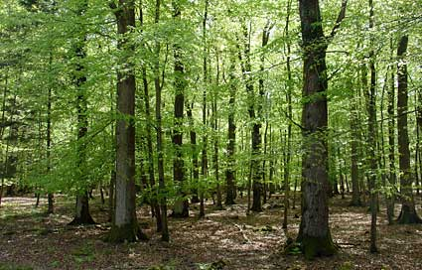

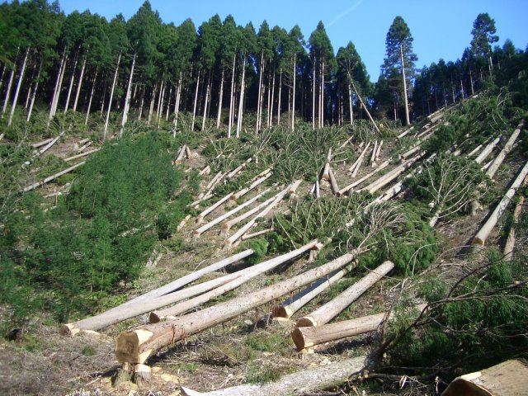 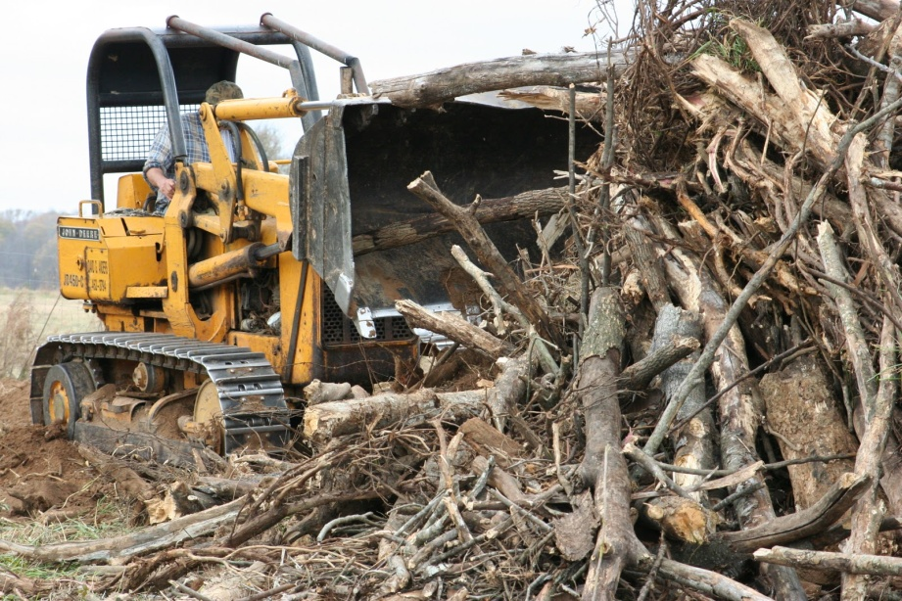 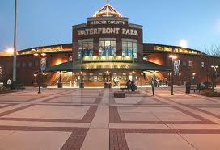

Dear Once-ler,

Please do not cut down all of our Truffula trees! Although it would be nice to have a ________________ built, deforestation is bad for the environment. Deforestation makes me feel ___________________. It is bad for the environment because _____________________________________ ___________________________________. It is also bad because ______________________________________________________________________. I speak for the trees! I hope that you will leave them be.

Sincerely,

___________

|  |  |
| --- | --- |
| Before Deforestation | After Deforestation |
|  |  |